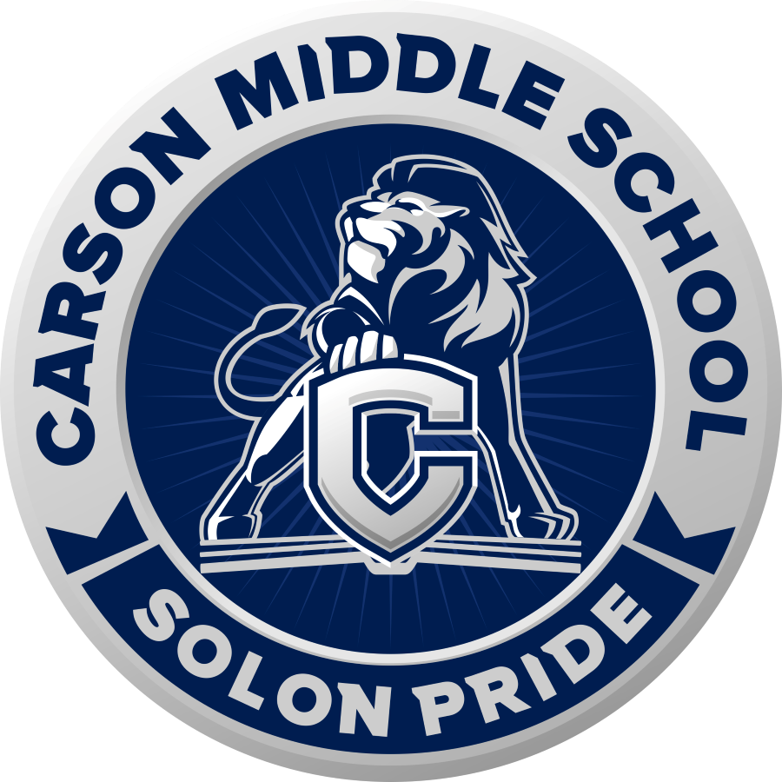

CMS Band Handbook
2021-2022
*Enrollment in Carson Middle School Bands is conditional upon agreement to this document in its entirety.

Table of Contents

COVID-19 Statement 3
Required Materials 3
Instrument Rentals 4
Band Fee 4
Grading Policies 5
Late Work Policy 6
At-Home Practice Requirements 6
Technology Requirements 7
Smart Music 7
Tone Savvy 7
Phone Use 7
Behavior Expectations 8
Performances 8
Missing a Performance 8
Alternate Assignment 9
Concert Attire 9
Marching Band Attire 9
Travel 9
Calendar of Events 10
Local Music Businesses 11
Private Lessons Teachers 12
Director Contact Information 12

COVID-19 Statement
In compliance with state and district guidelines, the following safety precautions will be observed during the 2021-2022 school year:

- Students have the option to wear face coverings and bell covers if they or their families so choose. Bell covers can be purchased here or anywhere that sells instrument bell covers.
- COVID testing is currently required prior to any travel outside of the county. More information on this is forthcoming and will be shared in a timely manner.

Required Materials
Students will receive daily points toward their citizenship grade by being ready for class with the following materials:

- Instrument
- Music Folder
- Method Book (optional, but preferred)
  - We will use the Standard of Excellence series. Please check with your Band Director to find out which book is required for your class.
- Pencil
- ChromeBook and Charger
- Instrument Accessories
  - These are specific to each instrument, but may include reeds, oils, neck straps, cleaning swabs, etc.
  - Accessories can be purchased from local music businesses or from CMS Bands

Instrument Rentals
Carson Middle School has a limited number of school-owned instruments that can be rented to students for $75.00 per school year. This rental fee covers the cost of repairing normal wear and tear as well as a professional chemical wash over the summer. Families wishing to rent a school instrument will need to fill out a rental agreement and return it to the director before receiving the instrument.

Priority is given to students who qualify for free-and-reduced meal plans through the district. After these students, priority is on a first-come-first-served basis. If the school cannot rent an instrument to every student, there are outside businesses able to provide rental instruments for a monthly fee. Often these businesses offer a rent-to-own program for families interested in purchasing a quality instrument. Please see the Local Music Businesses page for more information.

Students may also bring instruments they own or may purchase an instrument from a reputable source. It is always a good idea to check with your band director or private lessons teacher before purchasing an instrument. There are many brands that are not designed to last more than 6 months. Once these break, they will be impossible to repair. Quality instruments may become damaged with normal wear and tear, but are able to be repaired year after year.

Band Fee
Participation in CMS Bands costs $35.00 for the school year. This fee pays for Smart Music enrollment, the required concert shirt, as well as entrance fees to events such as the Nevada Day Parade, Sparks Hometowne Christmas Parade, NZNMEA Band Festival, NZNMEA Honor Band, and other events.

Grading Policies
- Playing Tests - 30%
  - Either In-Class or through Smart Music
- Assignments - 30%
  - Practice Logs
  - Sectional Forms
  - Compositions
  - Other Assignments
- Performances - 40%
  - There will be at least one required performance each quarter.
- Citizenship
  - Students will respond to a “readiness check” each day in class. They can earn up to 6 points each day or 30 points each week. Excused absences and no-school days will count as 6 points. Unexcused absences will count for 0 points.
    - Instrument - 2 pts
    - Music Folder - 2 pts
    - Pencil - 1 pt
    - Instrument Accessories - 1 pt

4 | 30 points plus outstanding acts of kindness (picking up trash, fixing chairs/stands, helping another student, etc.)
3 | 21-30 points
2 | 11-20 points
1 | 0-10 points

Typical Assignment Schedule:
Mondays: Playing Tests
Thursdays: Sectional Forms Due
Fridays: Practice Logs Due

Late Work Policy
Students are responsible for turning their work in on time. This is an important life-skill that students will use in the professional world as well as in the classroom. Late assignments will be accepted within the same concert cycle (typically each quarter). Assignments turned in after a concert (excluding alternate concert assignments) will not be accepted.

At-Home Practice Requirements
Students are expected to practice at home every day. No specific amount of time is required, but students should expect to practice a minimum of 10 to 15 minutes each day. Practice Cards will be collected every Friday. If practicing at home is impossible, students are able to practice at school during the following times:

- Before School (7:15-7:45)
- At Lunch - All lunches available
- During Encore - IF ENCORE TEACHER ALLOWS
- After School (2:25 - 3:30)

These times are specifically for students who cannot practice at home. We can best utilize our limited space if students who are able to practice at home do so.

Technology Requirements

Smart Music
Students are expected to use Smart Music primarily as a practice tool, but also to submit assignments either by recording their playing or composing musical examples. Students will be taught how to navigate the program and how to be successful in their recordings. Recordings will be done outside of class and will require a quiet location for the student to record. Any questions or concerns will need to be addressed with the Band Director.

Tone Savvy
Tone Savvy is a website we will be using this year to train our ears to better hear notes in relation to one another. Students will be expected to complete a short assignment each day as they come into class. Once an assignment is “fulfilled,” the assignment will be given a 100%. Students should be completing at least one assignment per week.

Phone Use
Students will have the option to utilize recommended music apps in class, but will have their phones taken if they are off-task. Phones which are confiscated will be returned according to the Carson Middle School Phone Policy.

Recommended Music Apps:
- Tuner
  - Tonal Energy ($3.99)
  - Bandmate (highly recommended)
  - Pano Tuner
- Metronome
  - Soundbrenner
  - Metronome Plus
  - Smart Metronome

Behavior Expectations
Being a member of the Carson Middle School Band Program is a privilege. Students in this program travel a great deal and represent our school every day. It is important that Band Members display exemplary behavior at all times.

CMS Band Members will:

Be Safe
Be Responsible
Be Respectful
Value Learning

Students who do not meet behavior expectations will experience the following:
1st Offence: Warning
2nd Offence: Student will complete Written Behavior Expectation Assignment
3rd Offence: Phone Call Home and student complete written Behavior Expectation Assignment
4th Offence: Referral to the Office

Students who have received referrals to the office will not be allowed to travel and will need to complete alternate assignments. Students who continue in this pattern will lose the privilege of being a member of the Carson Middle School Band Program.

Performances
There will be multiple evening performances throughout the school year. At least one performance each quarter will be required and will count as 40% of the student’s overall grade. Please see the Calendar of Events for more information.

Missing a Performance
Performances are mandatory and will count as 40% of a student’s grade. However, students with the following circumstances will be excused from attending a concert:

- Illness
  - Student did not attend school that day
- Family Emergency
  - Requires a signed note from a parent within a week of the performance
- Pre-arranged Absence
  - Student must provide 3 weeks notice so their part can be learned and performed by another student

Alternate Assignment
Students who have missed a performance for one of the reasons listed above may complete an alternate assignment for full credit. It is the responsibility of the student to ask for this alternate assignment. Students will have one week to complete the assignment.

Concert Attire
Students are required to wear their band shirt, black pants, black socks, and black shoes for all concerts unless otherwise stated. This gives the group a uniform and professional look which stems from industry standards. Students will order their t-shirt during the first month of school.

Marching Band Attire
The Carson Middle School Marching Band will provide jackets to members of the marching band. Students are responsible for the care and maintenance of these jackets. These jackets are the property of Carson Middle School and are to be returned in good and clean condition.

Travel
As long as the District and State allow, our bands will be on the move this year! Aside from our Festival Performances in Reno, we will also be taking the Intermediate Band to Six Flags in Valejo, CA and the Advanced Band to Disneyland (out of state trips are optional). Other travel opportunities include Honor Band (Carson City), All-State Band, and Band-o-Rama (Carson City).

As per the Governor’s Directive 048, COVID testing will be part of travel requirements. Unvaccinated extra- and co-curricular students and staff will require testing if they have plans to leave the "county" for purposes of school activities like competitions, concerts, or field trips. These tests will be scheduled and will not be held during school hours. If a student or a staff member becomes symptomatic or is identified through contact tracing as one who may have been in close contact with a person who has tested positive, a test will be administered, and appropriate steps taken. This is essentially the same testing process that was used last year. We will not be doing "random" testing or screening on the unvaccinated population but will respond accordingly when symptoms occur.

In order to travel with the Bands, students must be passing ALL of their classes and have no referrals to the office. Students who do not meet these requirements WILL NOT be allowed to travel.

Calendar of Events
The following dates are subject to change and additional dates may be added. Information about changes will be communicated in a timely manner.

- 8th Grade Night at CHS: September 10, 2021
  - 8th Grade students will be able to rehearse and perform with the Blue Thunder Marching Band at Carson High School.
- Fall Concert: October 7, 2021
  - All Band Classes will showcase what they have learned in the first quarter.
- Nevada Day Parade: October 30, 2021
  - Marching Band will perform in this parade in conjunction with EVMS.
- Sparks Hometowne Christmas Parade: December 4, 2021
  - Marching Band will perform in this parade in conjunction with EVMS.
- Winter Concert: December 9, 2021
  - All Band Classes will showcase what they have learned in the first semester.
- Elementary Tours: TBD

- Honor Band: TBD
  - Students will have the opportunity to audition for Honor Band. Those who are selected will rehearse and perform during these two days.
- Solo and Ensemble: February, 2022
  - Advanced Band students are required to prepare a piece for solo and ensemble. Students in other classes are able to participate if they would like.
- Jazz in the Schools: February, 2022
  - Jazz Band will perform for judges.
- NZNMEA Festival: TBD
  - Intermediate and Advanced Bands will perform for judges.
- Band-o-Rama: March 17, 2022
  - This event will be at Carson High School and will include the following groups:
- All-State: April 7-9, 2022
  - Students who participated in Honor Band will have the opportunity to audition and perform for All-State in Reno.
- Six Flags Trip: April 30
  - Intermediate Band will perform for the Music in the Parks festival. More information to follow.
- Disneyland Trip: May 11-13
  - Advanced Band will participate in a studio sight reading clinic. More information to follow.
- Spring Concert: May 19, 2022
  - All Band Classes will showcase what they have learned throughout the school year.
- 8th Grade Promotion: June 3, 2022
  - 6th and 7th grade students may elect to perform for the ceremony.

Local Music Businesses
Business | Contact Information | Services
Absolute Music | Website:  https://absolutemusiconline.com/  Email:  absolutemusic@sbcglobal.net  Address:  8175 S Virginia St #600, Reno, NV 89511, USA  Phone:  775-852-2637 | Instrument Rentals, Accessories, Method Books, Repairs
Blue Note B’s Horn Shop | Website: https://bnbinstruments.com/  Email: bnbinstruments@gmail.com  Address:  1525 Oddie Blvd, Sparks NV 89431  Phone:  775-453-9219 | Instrument Rentals, Accessories, Method Books, Repairs
Carpenter’s Music World | Website: https://carpentersmusic.com/  Address:  1090 Kietzke Lane  Reno, NV, 89502  Phone:  (775) 852-7618 | Instrument Rentals, Repairs
Play Your Own Music | Address:  112 E John St, Carson City, NV 89706  Phone:  (775) 885-7529 | Accessories, Method Books
Silver and Brass | Address:  710 N Curry St, Carson City, NV 89703  Phone:  (775) 691-9737 | Brass Accessories, Brass Instrument Repairs

Private Lessons Teachers

Flute:
Aliyah Saldarriaga
aasaldarriaga13@gmail.com
https://spark.adobe.com/page/nfEQJx76eGTxL/

Clarinet:
Amy Kohler
amyckohler@gmail.com

Double Reeds (Oboe and Bassoon):
Benjamin Benson
benjamin.benson@washoeschools.net

Saxophone:
Ryan Stewart
rstewart@nevada.unr.edu

Trumpet:
Tayler Duby
taylerduby.trumpet@gmail.com

F Horn:
Victoria Blue
vblue@nevada.unr.edu

Trombone:
Dominick Van Orman
dvanorman@carson.k12.nv.us

Jillian Ochsendorf
Jochsendorf@nevada.unr.edu

Baritone/Euphonium/Tuba:
Axel Garcia Vega
Garciav.axel@nevada.unr.edu

Percussion:
Brandon Dodge
gaming_man@live.com

Jon Brill
jbrill@carsin.k12.nv.us

Director Contact Information
Mrs. Van Orman
Carson Middle School
Director of Bands
Northern Zone Representative
svanorman@carson.k12.nv.us (Best Choice!)
ParentSquare
775-283-2867

